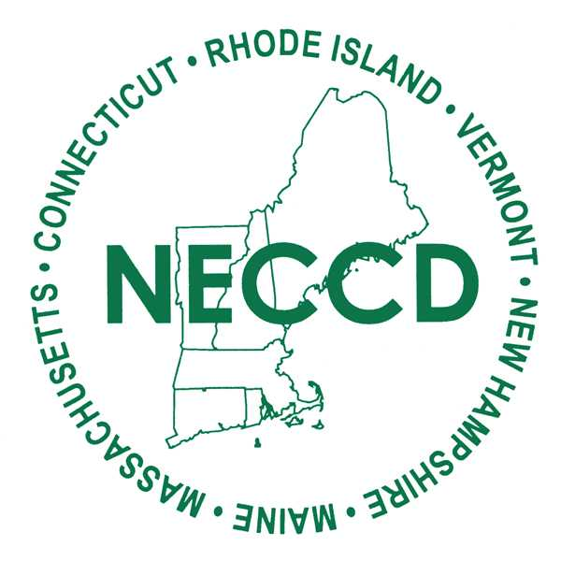

New England Council on Crime and Delinquency

PO Box 891, North Andover, MA 01845
www.neccd.net

< Date >

Dear < Manager >,

I’d like to request permission and funding to attend the New England Council on Crime and Delinquency (NECCD) 85th Annual Training Institute in South Portland, Maine on November 9-6, 2024. NECCD’s annual training institute offer a unique opportunity to attend numerous educational sessions, assess available resources, and network with other leaders in the industry.

With three plenary sessions and more than 15 breakout workshops, I’ve identified numerous sessions which make this year’s training institute essential to my work as a community corrections professional. The offerings address many of the issues we face while providing ideas and information to help me stay ahead of the challenging work required in this environment. Following the training institute, I will share best practices, contacts, resources, tools, and trends with you and my co-workers.

To help with your decision, the cost to attend the institute is:
Registration: $325/individual member; $400/non-member

I don’t want to miss out on this educational content and having representatives from < Your Agency Name > at this training will allow us to gain valuable insight and information that will create lasting change in our community corrections world. You can find more information about the 85th Annual Training Institute by visiting NECCD’s website, https://www.neccd.net/.

Thank you for your thoughtful consideration of my request.

Sincerely,

< Your Name Here >

President
Jodie Johnson
Maine
Office: 207-474-7378
Cell: 207-215-5799
jodie.johnson@maine.gov

Vice President
Eric Skillings
New Hampshire
603-860-5949
eric.j.skillings@dhhs.nh.gov

Treasurer
Amy Jacobs
Vermont
802-527-4347
amy.jacobs@vermont.gov

Secretary
Amber Charbonneau
Vermont
802-865-1364
amber.charbonneau@vermont.gov

Executive Director
Julie Bjelko
Maine
207-441-8743
julie.bjelko@maine.gov

